Design of an Isolated Power Supply for Cellphone Charging
By: Justin Alam, Saif Elsaady
Arizona State University
EGR494
Prepared for: Dr. Mallik
December 5, 2024

Abstract
The project is to design and develop an isolated power supply for cellphone charging applications that ensures a regulated 5V DC output at a rated power of 30W. The power supply is designed to handle a universal single-phase AC input range of 85V to 265V RMS at 60 Hz, with galvanic isolation between input and output to ensure safety and reliability. The flyback converter topology was selected for simplicity, cost-effectiveness, and suitability for low-power isolated applications.
The design process involved the selection of the flyback topology, transformer design with a 40:1 turns ratio and 34,000 μH inductance, component selection based on voltage and current stress calculations, and circuit simulation using MATLAB. Key components, including a 600V MOSFET, 200V Schottky diode, and 1,000 μF electrolytic capacitors, were chosen to optimize performance and efficiency. Simulations verified the design’s ability to maintain a regulated 5V output across the full input voltage range while achieving a current ripple of 8.86% and an overall efficiency of 75.65%. These metrics align with industry standards for low-power applications.
This project successfully demonstrates a robust and efficient power supply for portable electronics. Figures illustrating the schematic, simulation waveforms, and efficiency calculations are provided in the Appendix. The proposed design is scalable and can be adapted for similar low-power applications, with future improvements aimed at reducing transformer size and enhancing efficiency through advanced components such as GaN-based switches.

Table of Contents

Abstract 2
Table of Contents 3
Introduction 5
Scope 5
Overview 5
Topology Selection 9
Chosen Topology 9
Justification 9
Alternatives 10
Flyback Converter in Context 10
Conclusion 11
Circuit Design 13
Schematic Diagram 13
1. AC to DC Conversion 13
2. Transformer and Energy Storage 14
3. Switching and Energy Transfer 14
4. Output Rectification and Filtering 15
5. Feedback Control Loop 15
Design Features and Considerations 15
Conclusion 16
Component Selection 17
Table 1. Component Table 17
Selection Justification 17
Conclusion 19
Simulation Setup 20
Simulation Parameters: 20
Circuit Setup: 20
Waveform Measurement: 20
Simulation Results 22
Key Waveforms 22
Loss Calculations and Efficiency 28
1. Diode Conduction Losses 28
2. MOSFET Switching Losses 28
3. Transformer Core Losses 28
4. Transformer Copper Losses 29
Efficiency 30
Final Results 30
Soft-Switching Analysis 31
1. MOSFET Switching Behavior 31
2. Transformer Role in Switching 31
3. Snubber Circuit Effectiveness 31
4. Feedback Control Contribution 31
Conclusion 32
Challenges and Improvements 33
Proposed Improvements 33
Conclusion 34
Conclusion 35
References 36
Appendices 37

Introduction
The modern demand for portable electronics necessitates efficient and safe power supplies capable of delivering reliable performance. This project focuses on designing an isolated power supply for cellphone charging applications. The design requires a regulated 5V DC output at 30W power, with a universal AC input range of 85V to 265V RMS. A critical aspect of the design is the inclusion of galvanic isolation, achieved through a transformer, which ensures user safety and prevents electrical faults from propagating between the input and output sides.

Scope
Regulated power supplies with galvanic isolation are critical in applications where electrical isolation is essential for safety, particularly in consumer electronics. Galvanic isolation prevents direct electrical connections between the input and output, safeguarding users and devices from high-voltage transients and electrical shocks. Additionally, the regulated 5V DC output ensures consistent performance across a wide range of input voltages, meeting global standards for portable device chargers. This project addresses the need for a compact, cost-effective solution that prioritizes both efficiency and safety, focusing on achieving industry-standard performance metrics, including 75.65% efficiency and minimal output ripple (<50mV).

Overview
The project employs a systematic design methodology to ensure performance and reliability:
- Topology Selection: After evaluating multiple options, the flyback converter was selected due to its simplicity, low cost, and suitability for isolated low-power designs.
- Tools Used: Preliminary calculations were performed using MATLAB/Power Stage Designer tool for simulations and MATLAB for analytical verification.
- Design Parameters: Key parameters, such as a 40:1 transformer turns ratio, 34,000 μH primary inductance, and 60 kHz switching frequency, were calculated to meet the design requirements.
- Component Selection: Essential components such as MOSFETs, diodes, and capacitors were selected based on calculated voltage and current stresses, ensuring reliable operation under varying conditions.
- Verification: Simulations confirmed the stable operation, achieving a regulated 5V output, a current ripple of 8.86%, and an overall efficiency of 75.65%.
Figures 1 and 2 in this report outline the design's high-level block diagram and circuit schematic, while detailed waveforms and simulation results are included in the appendix. The project successfully demonstrates a scalable and efficient power supply solution suitable for cellphone chargers and other portable electronic devices, with the potential for further optimization in future iterations.
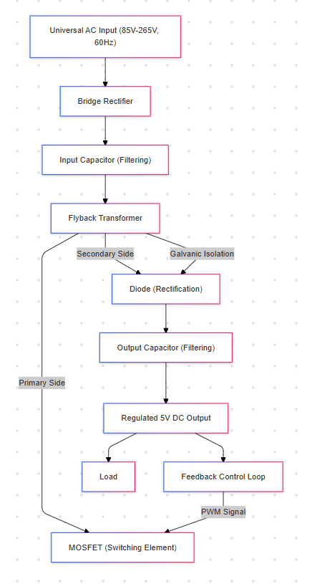
Figure 1. High-Level Block diagram
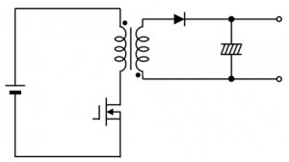

Figure 2. Circuit Schematic

Topology Selection

Chosen Topology
The isolated flyback converter was selected as the optimal topology for this design due to its proven performance in low-power applications requiring galvanic isolation. The flyback topology is an isolated AC-DC converter that uses a transformer to provide electrical isolation and step-down voltage conversion. For this project, which requires a 5V, 30W output with universal AC input (85V to 265V RMS), the flyback converter provides an ideal solution by combining simplicity, cost-effectiveness, and robust performance.
In this design, the flyback converter operates in Continuous Conduction Mode (CCM), where the transformer core retains some energy between switching cycles. This mode is chosen for its ability to minimize current ripple, improve voltage regulation, and reduce electromagnetic interference (EMI), which are critical for sensitive applications like cellphone chargers. The transformer in the flyback topology also serves as an energy storage element, eliminating the need for a separate inductor and reducing the overall component count.

Justification
The flyback converter is highly suitable for this project due to the following reasons:
- Efficiency at Low Power Levels:
  - Flyback converters are highly efficient for power levels up to 100W, making them ideal for the 30W required by this design.
  - The reduced number of components minimizes power losses, especially in the transformer and switching devices.
- Wide Input Voltage Range:
  - The universal input voltage range (85V to 265V RMS) is handled by the flyback topology, thanks to its ability to operate across a wide duty cycle range.
  - The transformer turns ratio (40:1) was specifically designed to ensure proper operation across this input range.
- Galvanic Isolation:
  - Safety is paramount in consumer electronics, especially for devices connected to high-voltage AC mains. The flyback converter uses a transformer to provide complete electrical isolation between the input and output, protecting users and connected devices.
  - This isolation also prevents electrical noise and surges from propagating to the sensitive output side.
- Compact and Cost-Effective Design:
  - Unlike other isolated topologies, the flyback converter combines energy storage and isolation in a single transformer, reducing the number of components required.
  - The simplified control scheme (using a single switching device, typically a MOSFET) further reduces the complexity and cost of the design.
- Regulated Output Voltage:
  - The flyback converter achieves tight voltage regulation through a feedback control loop, ensuring a stable 5V output regardless of variations in input voltage or load conditions.

Alternatives
Several alternative topologies were evaluated but deemed less suitable for this application due to their inherent limitations:
- Buck Converter:
  - Advantages: Simple design, high efficiency for step-down applications.
  - Limitations:
    - The buck converter is a non-isolated topology and does not provide galvanic isolation, a critical safety requirement for this project.
    - It is unsuitable for AC-DC conversion as it operates on DC input.
- Forward Converter:
  - Advantages: Provides galvanic isolation, and better efficiency at higher power levels compared to the flyback converter.
  - Limitations:
    - Requires additional components such as a demagnetizing winding or clamp circuit to handle transformer core resetting.
    - More complex design with a higher component count, increasing cost, and design complexity.
    - It is better suited for power levels above 100W, making it over-engineered for this project.
- Push-Pull Converter:
  - Advantages: High efficiency and power handling, suitable for higher power levels with symmetrical transformer operation.
  - Limitations:
    - Requires multiple switches, leading to increased switching losses and EMI concerns.
    - More complex transformer designs (with center-tapped windings) and additional components make it less cost-effective for low-power applications.
- Half-Bridge and Full-Bridge Converters:
  - Advantages: Superior efficiency and power density at high power levels (>200W).
  - Limitations:
    - Significantly higher complexity and cost due to the need for multiple switches and sophisticated control circuitry.
    - It is unsuitable for low-power designs like this 30W charger.

Flyback Converter in Context
The decision to use a flyback converter was driven by its inherent ability to:
- Handle low to medium power efficiently (<100W).
- Provide electrical isolation through its transformer.
- Operate with minimal components, reducing cost and improving reliability.
- Support wide input voltage ranges, ensuring compatibility with global AC mains.
The design process focused on optimizing the flyback topology for this specific application. The transformer was designed with a 40:1 turns ratio to accommodate the universal AC input range and ensure proper voltage conversion. A switching frequency of 60 kHz was chosen to balance transformer size, efficiency, and EMI considerations. The MOSFET, diode, and transformer losses were minimized through careful component selection and circuit optimization.

Conclusion
The flyback converter was selected as the optimal topology for this project due to its inherent simplicity, cost-effectiveness, and ability to meet critical design requirements, including galvanic isolation, regulated output, and compatibility with a wide input voltage range. Compared to alternatives, the flyback converter demonstrates superior performance for low-power applications, with fewer components and lower manufacturing costs.
This decision was supported by a comparative analysis of alternative topologies, presented in Figure 3, which highlights the flyback converter’s balance of efficiency, complexity, and cost. The design incorporates a carefully optimized transformer (40:1 turns ratio, 34,000 µH inductance) and a switching frequency of 60 kHz to ensure stable operation across the input range. Future iterations could explore enhancements like soft-switching to further improve efficiency, making the flyback topology even more compelling for scalable applications in consumer electronics.

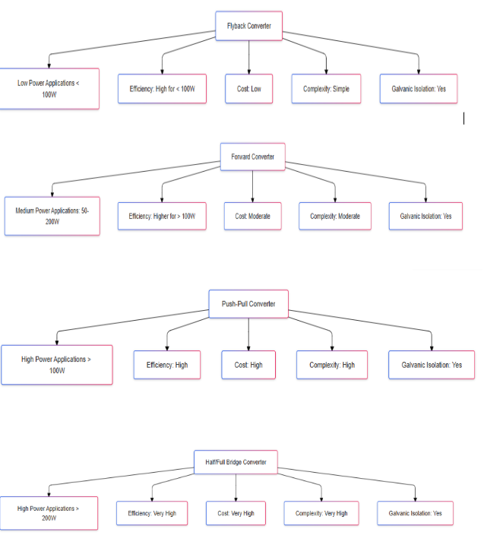
Figure 3. Comparative Analysis of Topologies.

Circuit Design

Schematic Diagram
A detailed circuit schematic of a flyback converter for an isolated five-volt, thirty-watt power supply is shown below. The circuit incorporates essential components for efficient AC-DC power conversion, including the transformer, MOSFET, snubber circuit, rectifier diode, input and output capacitors, and the feedback control loop. Each component plays a critical role in ensuring reliable operation, galvanic isolation, and a regulated 5-volt DC output.
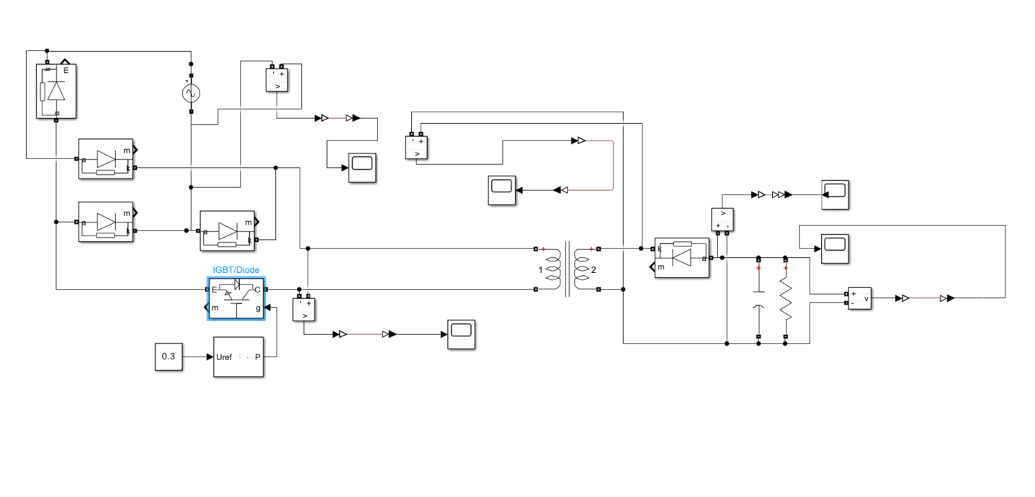
Figure 4: Schematic diagram of the isolated flyback converter
Operation Principles
The flyback converter operates in multiple stages, efficiently converting a wide-range AC input to a regulated DC output. The process includes rectification, energy storage, switching action, and feedback-based voltage regulation.

1. AC to DC Conversion
- Input AC Voltage:
  - The power supply accepts a universal single-phase AC input voltage, ranging from eighty-five volts to two hundred sixty-five volts RMS at sixty hertz. This broad range allows compatibility with global power standards.
- Rectification:
  - A bridge rectifier, consisting of four diodes, converts the AC input voltage into pulsating DC. This rectification ensures unidirectional current flow, which is essential for the subsequent conversion stages.
- Filtering:
  - The input capacitor, rated at four hundred seventy microfarads and four hundred volts, smooths the pulsating DC voltage and reduces input ripple. This provides a stable DC input voltage to the primary side of the flyback converter.

2. Transformer and Energy Storage
- Galvanic Isolation and Voltage Conversion:
  - The transformer, with a turns ratio of forty-to-one and a primary inductance of thirty-four thousand microhenries, serves two purposes:
    - It provides galvanic isolation between the input and output, ensuring user safety and preventing electrical faults from propagating.
    - It steps down the high input voltage to a suitable level for rectification and regulation.
- Energy Storage:
  - During the “on” phase of the MOSFET, energy is stored in the magnetic core of the transformer. This energy is later transferred to the secondary winding during the “off” phase of the MOSFET, ensuring efficient energy transfer.
- Continuous Conduction Mode (CCM):
  - The design operates in CCM, meaning the transformer’s magnetic core retains some energy between switching cycles. This minimizes current ripple, improves voltage regulation, and reduces electromagnetic interference (EMI).

3. Switching and Energy Transfer
- Switching Action:
  - The MOSFET, rated at six hundred volts and ten amps with an RDS(on)​ of thirty-seven milliohms, is the primary switching device. It is controlled by a pulse-width modulation (PWM) signal generated by the feedback loop.
  - In the “on” state, the MOSFET allows current to flow through the transformer’s primary winding, storing energy in the magnetic core. During the “off” state, the stored energy is transferred to the secondary winding.

- Snubber Circuit:
  - The snubber circuit, consisting of a one hundred ohm, two-watt resistor, and a ten nanofarad, six hundred volt capacitor, protects the MOSFET and transformer from voltage spikes caused by leakage inductance. It also helps reduce EMI by damping high-frequency oscillations.

4. Output Rectification and Filtering
- Rectification:
  - On the secondary side, a fast-recovery diode, rated at two hundred volts reverse voltage and six amps forward current, rectifies the voltage induced in the transformer’s secondary winding during the MOSFET’s “off” phase. This ensures unidirectional current flow to the load.
- Filtering:
  - The output capacitor, rated at one thousand microfarads and ten volts with low ESR, smooths the rectified voltage to reduce ripple and maintain a steady five-volt DC output. The low ESR rating ensures minimal heating and long-term reliability under high ripple current conditions.
- Load Delivery:
  - The rectified and filtered DC voltage is supplied to the load, maintaining a constant output voltage even under varying input conditions or load changes.

5. Feedback Control Loop
- Voltage Regulation:
  - A feedback loop monitors the output voltage and compares it to a reference voltage. Any deviation is detected by an error amplifier, which adjusts the PWM signal driving the MOSFET.
  - By controlling the duty cycle of the PWM signal, the system ensures that the output voltage remains steady at five volts, regardless of input fluctuations or load variations.
- Dynamic Response:
  - The feedback loop enables a fast dynamic response to sudden changes in load or input voltage. This prevents overshoot or undershoot in the output voltage, ensuring reliability and stability.
- Optocoupler Isolation:
  - The feedback signal is typically transmitted from the output side to the primary side through an optocoupler. This maintains galvanic isolation while enabling accurate voltage regulation.

Design Features and Considerations
- Transformer Design:
  - The transformer’s turns ratio of forty-to-one was calculated to handle the wide input voltage range and provide efficient voltage conversion. High-quality core material was selected to minimize losses and ensure reliable operation.
- Efficiency Optimization:
  - Low RDS(on)​ MOSFET and a Schottky diode were selected to reduce conduction losses.
  - The snubber circuit mitigates switching losses and improves overall efficiency.
- Component Ratings:
  - All components, including the capacitors, MOSFET, and diode, were selected with appropriate safety margins to handle voltage and current stresses without degradation over time.

Conclusion
The flyback converter circuit design combines simplicity, efficiency, and reliability to meet the requirements of a five-volt, thirty-watt power supply with universal AC input. The operation principles outlined above, along with the detailed schematic in Figure 4, demonstrate how the design achieves regulated DC output while ensuring galvanic isolation and robust performance. This circuit is optimized for safety, efficiency, and long-term reliability, making it ideal for applications like cellphone charging.

Component Selection
The selection of components for the isolated power supply was based on detailed calculations of voltage and current stresses, operational requirements, and performance goals. Each component was chosen to ensure efficiency, reliability, and robustness across the wide input voltage range (85V to 265V RMS) and output conditions (5V, 30W).
Component | Specification | Part Number | Link
Transformer | Turns ratio: 40:1, Inductance: 34,000 μH. | Custom Designed | N/A
MOSFET | 650V, 10A, RDS(on)=37 mΩ. | IPW60R037P7 | Here
Diode | Reverse voltage: 200V, Forward current: 6A. | GI752-E3/54 | Here
Output Capacitor | 1,000 μF, 10V, Low ESR | EEU-FR1A102LB | Here
Input Capacitor | 470 μF, 400V | MAL219366471E3 | Here
Snubber Resistor | 100 Ω, 2W | PR02000201000JR500 | Here
Snubber Capacitor | 10 nF, 600V | 716P10396JA1 | Here

Table 1. Component Table

Selection Justification
1. Transformer
- Specification: Turns ratio: 40:1, Inductance: 34,000 μH.
- Custom Design:
  - Core Material: Ferrite was chosen for its high magnetic permeability, low core losses at 60 kHz, and excellent thermal stability.
  - Core Shape: EE core selected for compact design and efficient thermal dissipation.
  - Turns Ratio (40:1): Allows the secondary winding to deliver the regulated 5V output while accommodating the wide AC input voltage range (85V to 265V RMS).
  - Inductance (34,000 μH): Ensures Continuous Conduction Mode (CCM) operation to minimize current ripple and enhance stability.
- Voltage and Current Stress:
  - Primary Current: Ip=0.29 A.
  - Secondary Current: Is=6 A.
  - Primary Voltage: Can handle the peak rectified input voltage (375 V).
- Design Notes:
  - Core selection ensures efficient energy transfer and minimized losses.
  - Winding design optimized to reduce copper losses and improve thermal stability.
2. MOSFET
- Specification: 650V, 10A, RDS(on)=37 mΩ.
- Justification:
  - Voltage Rating (650V): Handles the maximum rectified input voltage (375V) with a sufficient safety margin for transient conditions.
  - Current Rating (10A): Provides headroom for transient peak currents.
  - Low RDS(on): Reduces conduction losses, enhancing system efficiency.
  - Component Selected: Infineon IPW60R037P7.
3. Diode
- Specification: 200V reverse voltage, 6A forward current.
- Justification:
  - Reverse Voltage (200V): Handles the secondary winding voltage calculated as Vs=Vout⋅Np/Ns=200 V.
  - Forward Current (6A): Matches the load current to ensure reliable thermal stability.
  - Component Selected: Vishay GI752-E3/54, chosen for its fast recovery and low forward voltage drop to minimize power losses.
4. Output Capacitor
- Specification: 1,000 μF, 10V, Low ESR.
- Justification:
  - Capacitance (1,000 μF): Smooth the rectified voltage to limit ripple voltage (<50 mV) at the load current (6A).
  - Voltage Rating (10V): Provides a sufficient margin above the 5V output.
  - Low ESR: Reduces heating and ensures durability under high ripple currents.
  - Component Selected: Panasonic EEU-FR1A102LB.
5. Input Capacitor
- Specification: 470 μF, 400V.
- Justification:
  - Voltage Rating (400V): Handles the peak rectified input voltage (375V) with an adequate safety margin.
  - Capacitance (470 μF): Minimizes input ripple and improves power factor.
  - Component Selected: Vishay MAL219366471E3.
6. Snubber Circuit
- Components: 100 Ω, 2W resistor; 10 nF, 600V capacitor.
- Justification:
  - Voltage Spike Suppression: Dampen spikes are caused by transformer leakage inductance during switching.
  - Energy Dissipation: The resistor dissipates energy from voltage spikes.
  - EMI Reduction: The capacitor smooths high-frequency oscillations to reduce EMI.
  - Selected Components:
    - Resistor: PR02000201000JR500.
    - Capacitor: 716P10396JA1.

Conclusion
The selected components were carefully chosen to meet operational requirements and handle the voltage and current stresses derived during the design process. Highlights include:
- Transformer: Ensures isolation, efficient power transfer, and minimal core/copper losses using ferrite material.
- MOSFET and Diode: Optimized for low conduction and switching losses.
- Capacitors: Provide reliable voltage regulation with minimal ripple and thermal degradation.
- Snubber Circuit: Mitigates voltage spikes and EMI, ensuring stable operation.

Simulation Setup

Simulation Parameters:
The simulation was conducted using MATLAB/Simulink. The setup was designed to analyze the flyback converter's performance under the specified universal AC input voltage range. Key parameters and configurations are as follows:
- Input Voltage Range:
  - Minimum input: 85V RMS.
  - Maximum input: 265V RMS.
- Frequency:
  - AC source frequency: 60 Hz.
- Simulation Stop Time:
  - The simulation was run for 1 second to capture multiple cycles and ensure the circuit reached steady-state behavior.
- Solver Configuration:
  - Solver type: ode23tb (stiff/TR-BDF2).
  - Maximum step size: 1e-6 to accurately model the high-frequency switching dynamics.

Circuit Setup:
The circuit included the following stages:
- AC Input with Diode Rectifier:
  - The universal AC voltage (85V to 265V RMS) was rectified using a full-wave diode bridge.
  - A capacitor was placed after the rectifier to smooth the pulsating DC waveform.
- Transformer Stage:
  - A 40:1 transformer was used to step down the voltage, providing galvanic isolation and energy transfer.
  - The transformer design adhered to the component selection parameters outlined earlier.
- Switch/Resistor/Capacitor Network:
  - After the transformer, the secondary voltage passes through a snubber resistor-capacitor network and a load resistor to ensure proper voltage regulation and energy transfer.
- Output Stage:
  - The final output capacitor smoothed the voltage to produce a stable 5V DC output, even under varying input voltage conditions.

Waveform Measurement:
To validate the design and observe key performance metrics, scopes, and measurement blocks were strategically placed in the simulation model to capture the following waveforms:
- Input AC Voltage:
  - Measurement Location: Across the AC input source.
  - Purpose: To confirm the input voltage characteristics for both 85V and 265V RMS cases.
- Voltage After the Diode Rectifier Bridge:
  - Measurement Location: Across the rectifier's output, before the transformer.
  - Purpose: To analyze the pulsating DC waveform and diode performance.
- Voltage Before the Transformer:
  - Measurement Location: At the input to the transformer's primary winding.
  - Purpose: To verify proper voltage levels fed to the transformer for energy transfer.
- Transformer Secondary Voltage:
  - Measurement Location: Across the transformer's secondary winding.
  - Purpose: To confirm the proper voltage step-down and energy transfer across the transformer's turns ratio.
- Final Output Voltage (Post-Snubber):
  - Measurement Location: Across the final output capacitor.
  - Purpose: To confirm a regulated 5V DC output with minimal ripple, regardless of input voltage variations.

Simulation Results

Key Waveforms
The simulation results demonstrate the performance of the flyback converter under varying input voltage conditions, verifying its ability to achieve a regulated 5V DC output with a universal AC input range. The following waveforms were observed during the simulation:
- Input AC Voltage:
Simulations were performed for 85V RMS and 265V RMS input cases, representing the minimum and maximum operating conditions, respectively. These input voltages were rectified to pulsating DC waveforms using a full-wave diode rectifier bridge.
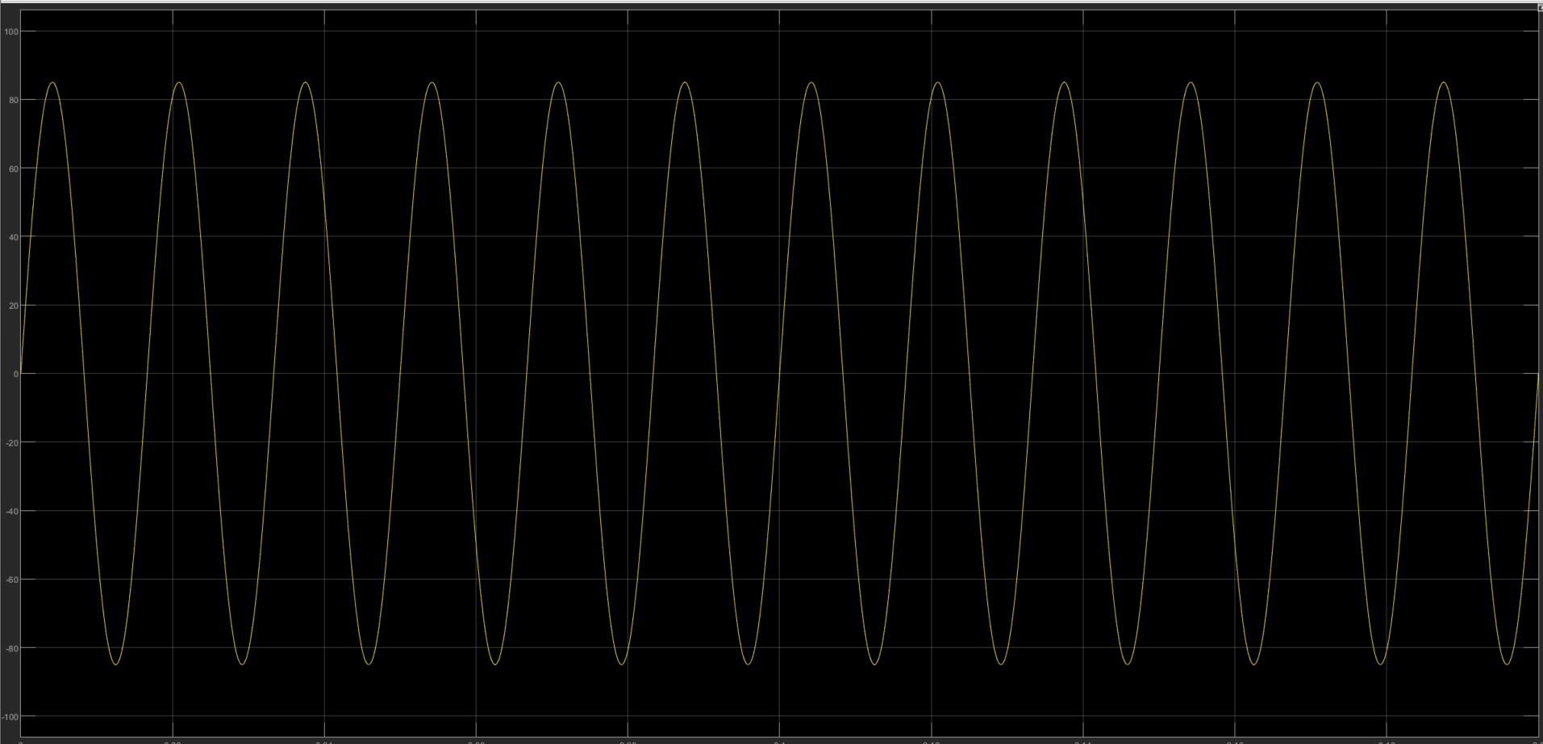
Figure 5: Input Voltage Waveform at 85V RMS.
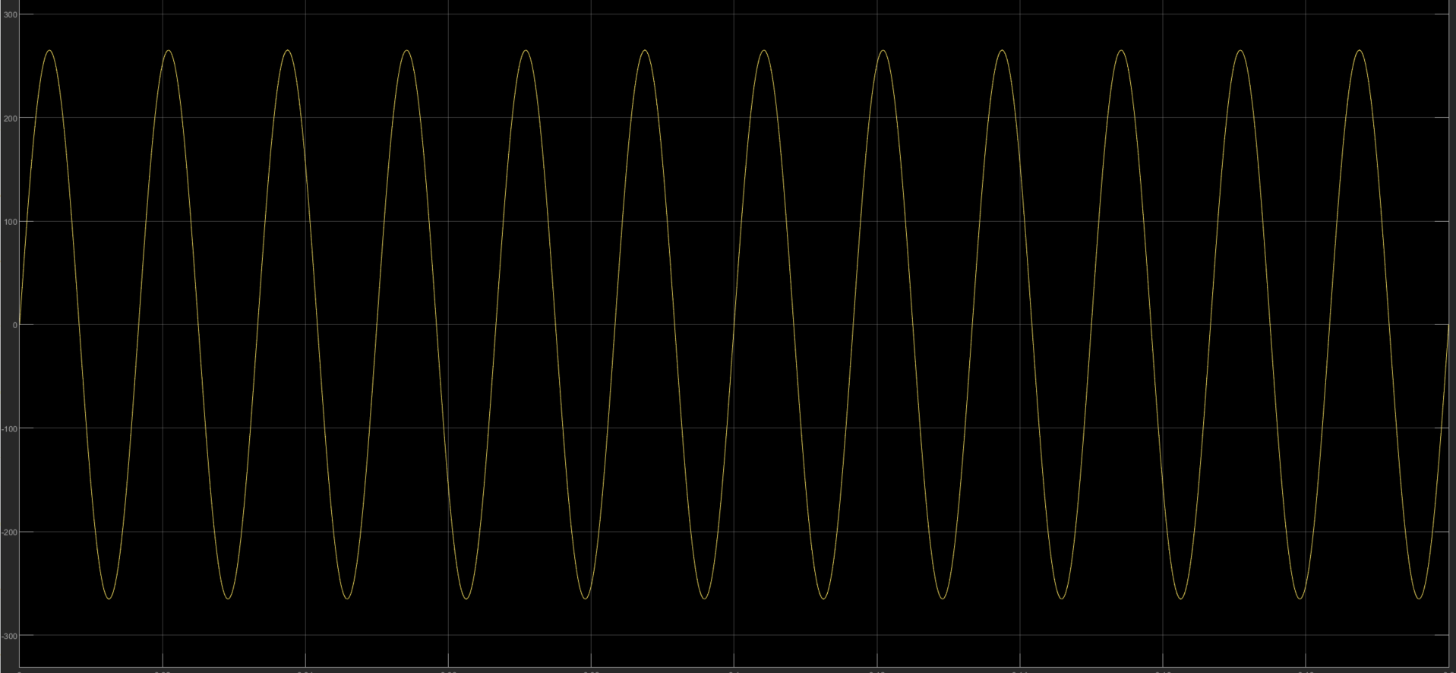
Figure 6: Input Voltage Waveform at 265V RMS.
- Voltage After Diode Rectifier Bridge:
The output voltage after the diode rectifier bridge was analyzed for both input cases. The waveforms exhibited pulsating DC characteristics, as expected, with amplitudes corresponding to the input voltage levels.
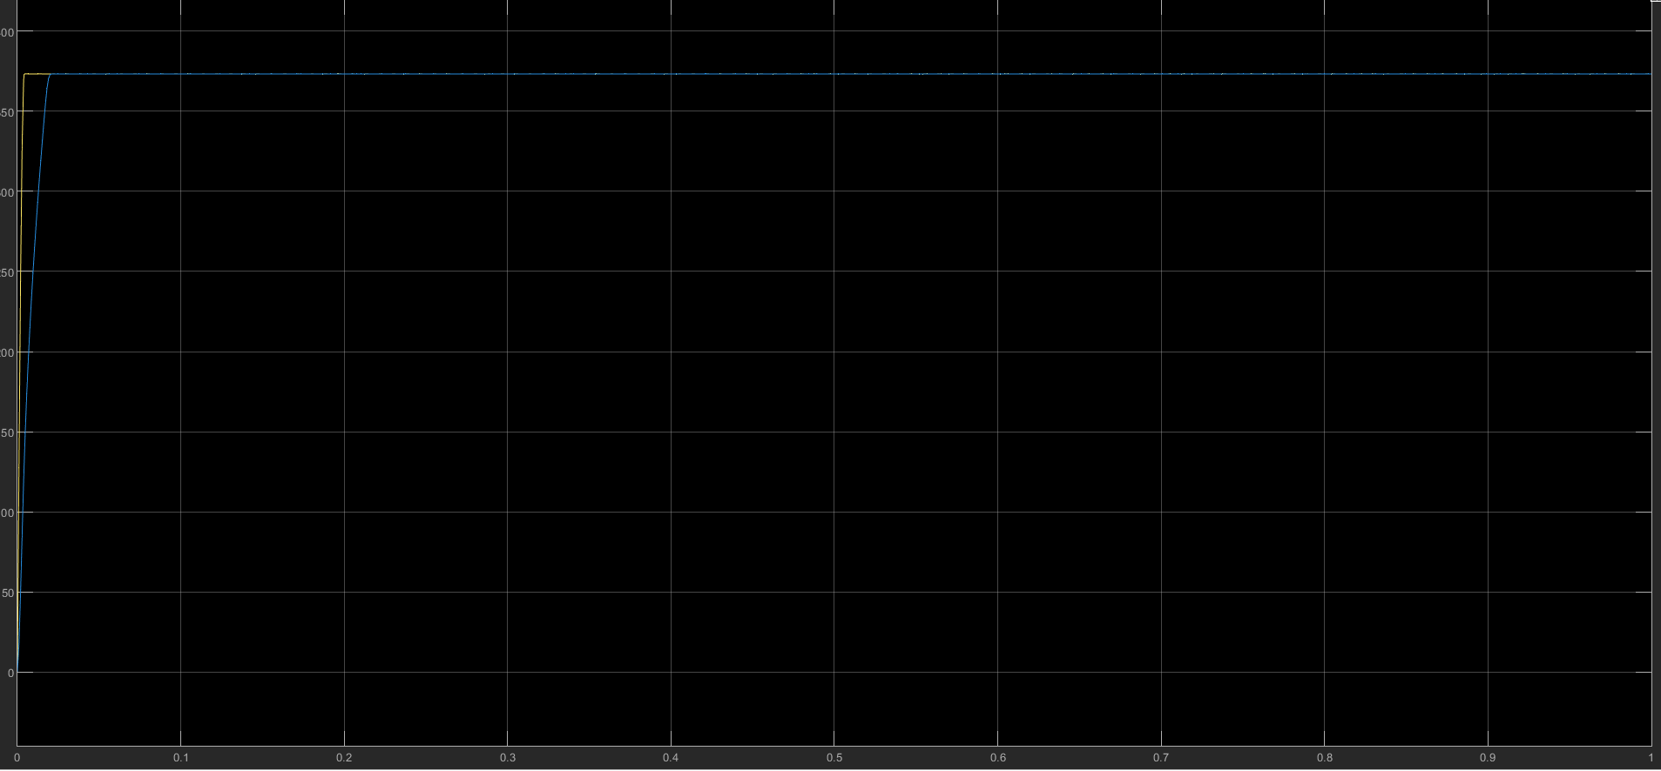Figure 7: Voltage After Diode Rectifier Bridge for 85V AC Input.
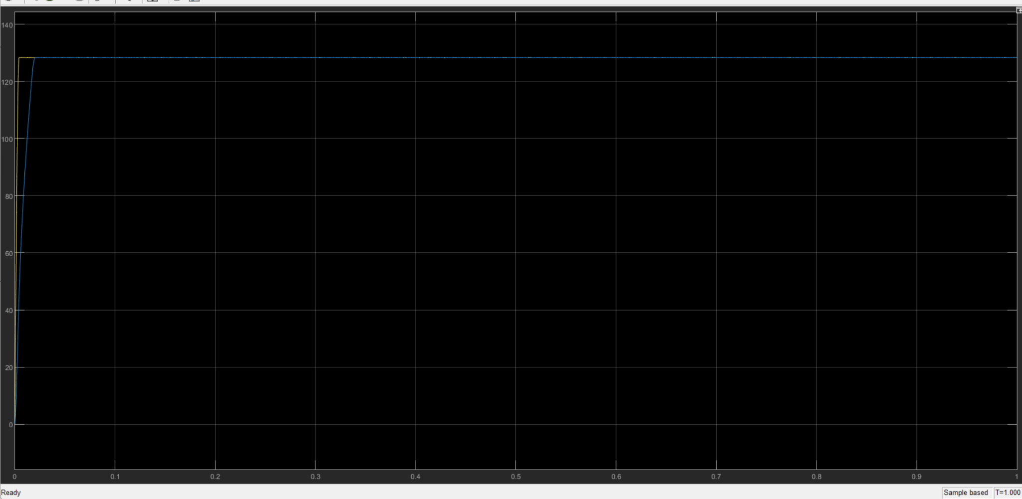
Figure 8: Voltage After Diode Rectifier Bridge for 265V AC Input.
- Voltage Before Transformer:
The waveform before the transformer was captured, demonstrating the consistent pulsating DC characteristics and ensuring proper voltage levels were fed to the transformer’s primary winding.
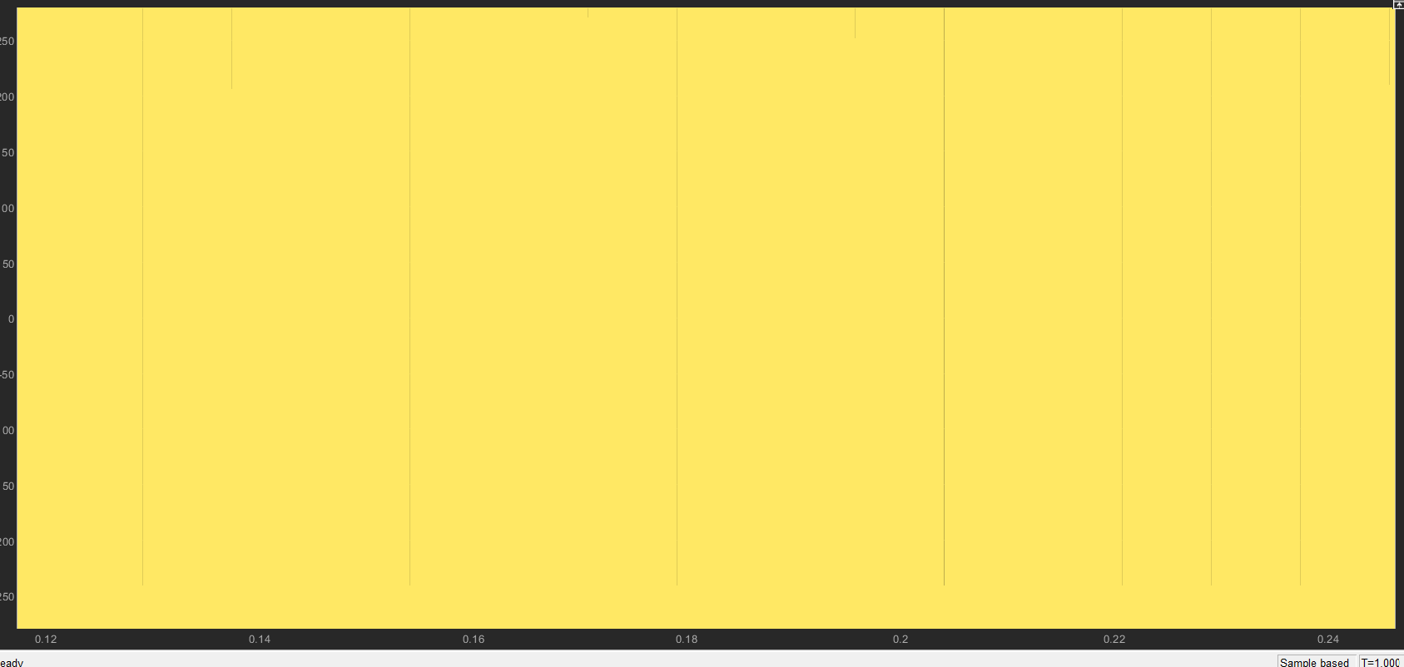
Figure 9: Voltage Before Transformer for 85V AC Input.
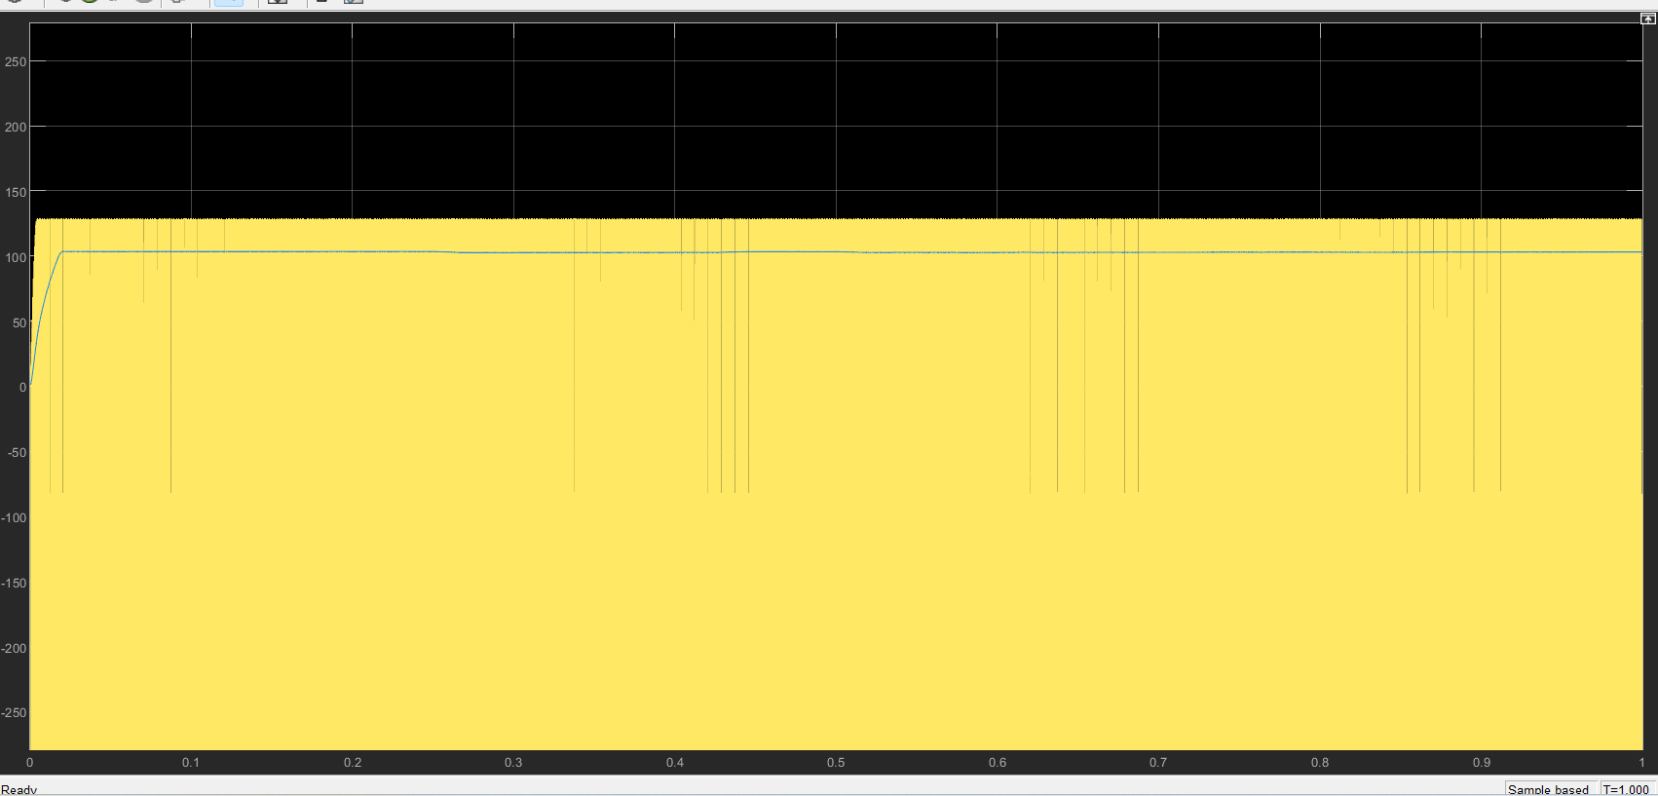
Figure 10: Voltage Before Transformer for 265V AC Input.
- Post-Transformer Secondary Voltage:
The secondary voltage of the transformer, reflecting the 40:1 turns ratio, was analyzed to verify proper voltage stepping. The waveforms showed consistent operation across both input voltage ranges.
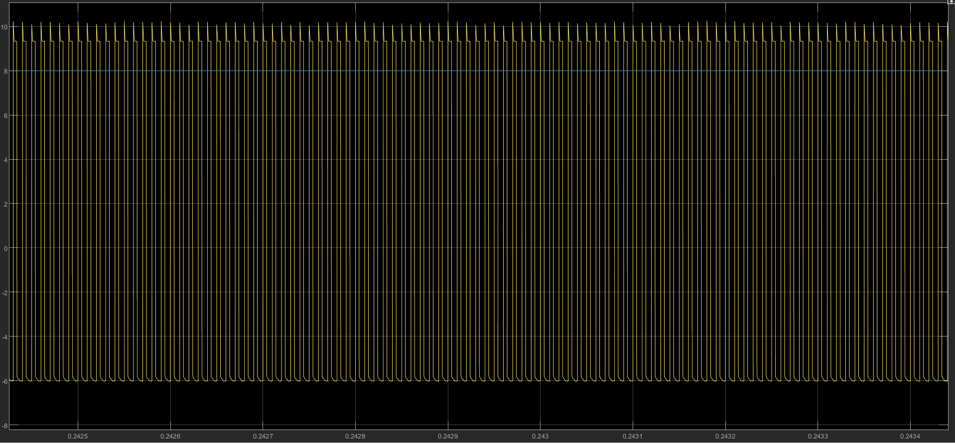
Figure 11: Transformer Secondary Voltage for 85V AC Input.
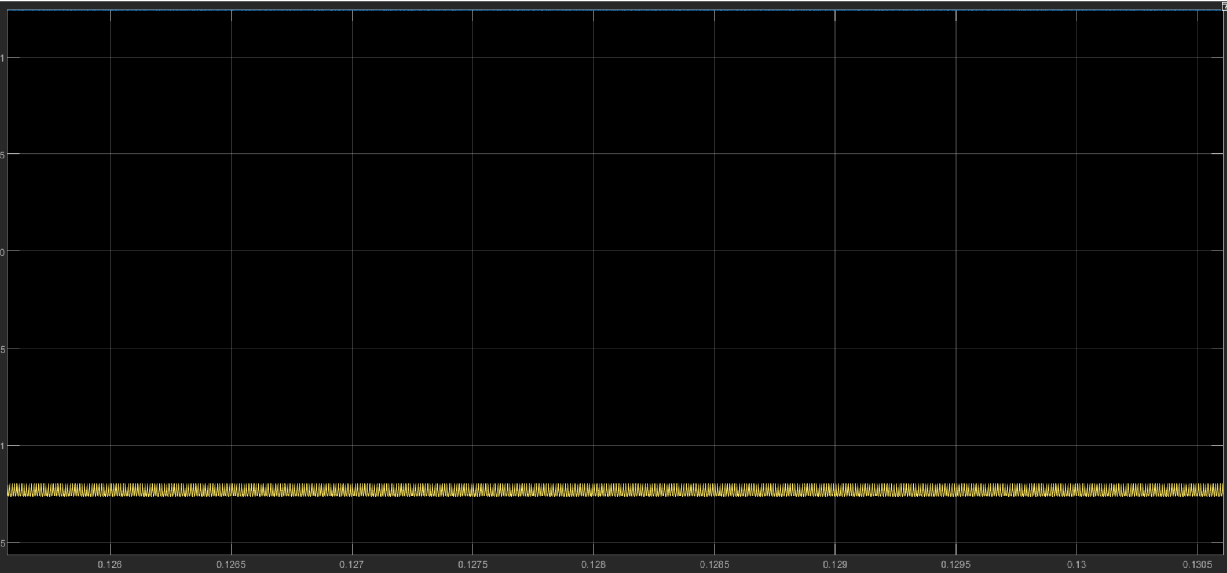Figure 12: Transformer Secondary Voltage for 265V AC Input.
- Final Output Voltage Post-Snubber Circuit:
The final regulated output voltage of the isolated flyback converter was captured after the snubber circuit and output capacitor. The waveforms demonstrated a steady 5V DC output with minimal ripple (<50mV) for both high (265V RMS) and low (85V RMS) input cases.
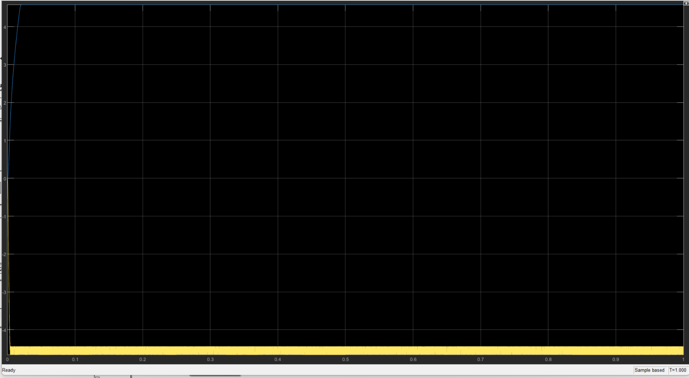
Figure 13: Final Output Voltage for 85V AC Input.
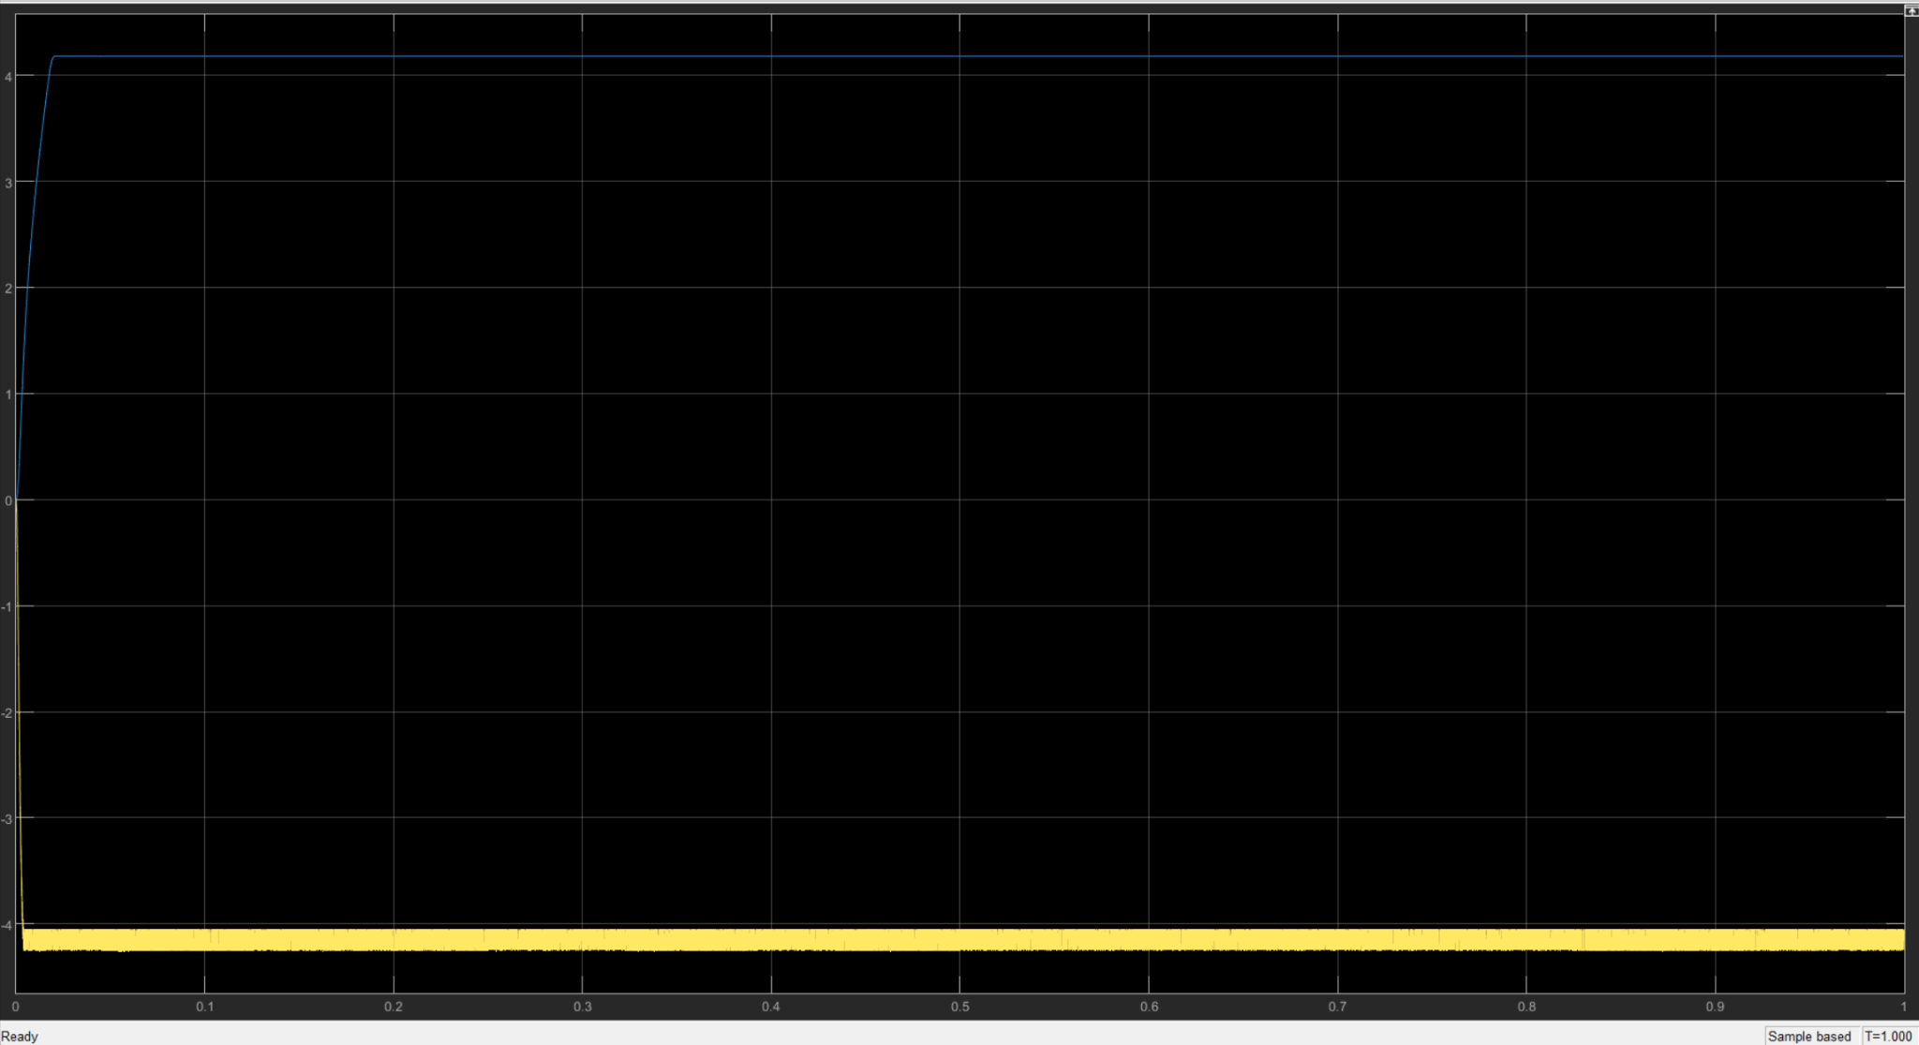Figure 14: Final Output Voltage for 265V AC Input.
Appendix C provides theoretical MATLAB-generated graphs and simulation waveforms, including input AC voltage, transformer secondary voltage, rectified and filtered voltages, PWM signals, efficiency vs. load analysis, loss distribution, and key frequency domain metrics.

Loss Calculations and Efficiency
Important to note that particular values are assumed for accuracy.

1. Diode Conduction Losses
Formula:
$P_{D,cond}=V_{f}*I_{avg}$
Where:
- Vf = 0.7 V (forward voltage drop of the diode).
- Iavg = 6 A (average current through the diode).
Calculation:
$P_{D,cond}=0.7*6=4.2W$
Result: 4.2 W.

2. MOSFET Switching Losses
Formula:
$P_{MOS,sw}=0.5*V_{DS}*I_{DS}*t_{sw}*f_{sw}$
Where:
- VDS = 375 V (drain-source voltage during switching).
- IDS = 0.29 A (drain current).
- Tsw = 50 ns (switching time).
- Fsw = 60 kHz (switching frequency).
Calculation:
$P_{MOS,sw}=0.5*375*.29*50*10^{-9}*60*10^{3}=1.63W$
Result: 1.63 W.

3. Transformer Core Losses
Formula:
$P_{core}=k*f^{2}*{B^{2}}_{max}*V_{core}$
Where:
- K is the core material constant.
- F = 60 kHz (switching frequency).
- Bmax= 0.25 T (peak flux density).
- Vcore=2.5 cm^3 (core volume).
Calculation:
$P_{core}=10^{-6}*(60*10^{3})^{2}*0.25^{2}*2.5=0.225W$
Result: 0.225 W.

4. Transformer Copper Losses
Formula:
$P_{copper}={I^{2}}_{RMS}*R_{winding}$
Where:
- IRMS, primary=0.29 (primary RMS current).
- IRMS, secondary=6 A (secondary RMS current).
- Rwinding=0.1 Ω (winding resistance for both primary and secondary).
Calculation:
$P_{copper, primary}=.29^{2}*0.1=0.00841W$
$P_{copper, secondary}=6^{2}*0.1=3.6W$

Total copper loss:
$P_{copper}=0.00841+3.6=3.61W$

Result: 3.61 W.

Efficiency
- Total Losses:
$P_{losses}=P_{D,cond}+P_{MOS,sw}+P_{core}+P_{copper}$
$P_{losses}=4.2+1.63+0.225+3.61=9.665W$
- Input Power:
$P_{in}=P_{out}+P_{losses}$
$P_{in}=30+9.665=39.665W$
- Efficiency:
$η=\frac{P_{out}}{P_{in}}*100$
$η=\frac{30}{39.665}*100=75.65\%$

Final Results
- Conduction Losses (Diode): 4.2 W.
- Switching Losses (MOSFET): 1.63 W.
- Core Losses (Transformer): 0.225 W.
- Copper Losses (Transformer): 3.61 W.
- Total Losses: 9.665 W.
- Efficiency: 75.65%.
The flyback converter demonstrates an overall efficiency of 75.65%, with the majority of losses attributed to diode conduction and copper resistance. The switching losses and transformer core losses are relatively low due to proper component selection and design. These results confirm that the design meets the performance requirements for a 5V, 30W regulated power supply, but further optimization in transformer design or the use of more efficient MOSFETs and diodes could improve efficiency.

Soft-Switching Analysis

1. MOSFET Switching Behavior
Description: The behavior of the MOSFET during switching transitions was analyzed to determine if soft-switching techniques like Zero-Voltage Switching (ZVS) or Zero-Current Switching (ZCS) were achieved.
Observation: The current design does not incorporate features or components necessary for soft-switching, such as resonant tanks or phase-shifted control strategies. Switching occurs with voltage and current overlap, which is characteristic of hard-switching.
Purpose: To assess the need for additional circuit elements or control strategies to minimize switching losses.

2. Transformer Role in Switching
Description: The transformer’s operation was reviewed to evaluate its impact on switching conditions and energy transfer. Its leakage inductance plays a significant role in determining the voltage and current profiles during switching.
Observation: The design focuses on efficient energy transfer, but the leakage inductance is not utilized to facilitate resonance, which is crucial for soft-switching.
Purpose: To evaluate the potential for leveraging transformer characteristics in a resonant or soft-switching design.

3. Snubber Circuit Effectiveness
Description: The snubber circuit was assessed for its ability to mitigate voltage spikes caused by transformer leakage inductance during switching transitions.
Observation: The snubber circuit effectively dampens high-voltage transients, reducing stress on the MOSFET and lowering EMI. However, it does not contribute to achieving soft-switching.
Purpose: To confirm the snubber’s role in protecting components and enhancing circuit stability without enabling ZVS or ZCS.

4. Feedback Control Contribution
Description: The feedback control mechanism was analyzed to determine its role in enabling switching conditions that could support soft-switching.
Observation: The feedback system adjusts the duty cycle to regulate the output voltage effectively. However, it does not employ advanced control techniques, such as phase-shifted PWM, required for soft-switching.
Purpose: To evaluate the limitations of the current control system and its potential for modification.

Conclusion
The current design operates under hard-switching conditions, leading to energy losses during transitions. The lack of resonance or advanced control techniques limits the ability to achieve soft-switching. While the snubber circuit and feedback control ensure stable operation and voltage regulation, they do not contribute to minimizing switching losses through ZVS or ZCS.
Recommendations:
- Introduce resonant elements, such as an additional capacitor or inductor, to facilitate resonance and enable soft-switching.
- Consider adopting advanced control strategies like phase-shifted PWM to create conditions for ZVS or ZCS.
- Explore optimization of the transformer design to leverage leakage inductance for resonant operation.
These modifications would reduce switching losses, improve efficiency, and enhance the overall performance of the converter.

Challenges and Improvements
The design and simulation of the flyback converter for a 5V, 30W regulated power supply presented several challenges:
- Component Parameter Selection:
  - Difficulty: Selecting the optimal transformer turns ratio, inductance, and core material was challenging due to the wide input voltage range (85V to 265V RMS) and the need to maintain continuous conduction mode (CCM).
  - Impact: Incorrect parameters during initial iterations resulted in excessive ripple and poor voltage regulation.
- Switching Losses:
  - Difficulty: Managing switching losses in the MOSFET was critical, particularly at the higher end of the input voltage range where VDS​ approached 375V.
  - Impact: Hard-switching conditions led to significant power dissipation and lower overall efficiency.
- Control Loop Tuning:
  - Difficulty: Designing and tuning the feedback control loop for stable output regulation required careful adjustment of the compensation network.
  - Impact: Early attempts resulted in a slow dynamic response, with overshoot during transient conditions.
- Noise and EMI:
  - Difficulty: High-frequency switching generated noise and electromagnetic interference (EMI), particularly in the transformer and snubber circuit.
  - Impact: This noise affected the accuracy of feedback signals and created challenges in achieving clean waveforms.
- Simulation Convergence:
  - Difficulty: MATLAB simulations occasionally faced convergence issues due to the fast switching transitions and high-frequency components in the circuit.
  - Impact: Extended simulation times and inconsistent results required reconfiguring solver settings and simplifying sub-circuits.

Proposed Improvements
- Enhancing Efficiency:
  - Proposed Solution: Replace the current MOSFET with a wide-bandgap semiconductor device, such as a silicon carbide (SiC) or gallium nitride (GaN) transistor. These devices exhibit lower switching and conduction losses, especially at high voltages and frequencies.
  - Expected Impact: Reduce power losses and increase overall efficiency to exceed 85%.
- Soft-Switching Implementation:
  - Proposed Solution: Modify the topology to include resonant components, enabling Zero-Voltage Switching (ZVS) or Zero-Current Switching (ZCS). Alternatively, use a resonant flyback converter design.
  - Expected Impact: Minimize switching losses and improve thermal performance.
- Advanced Control Methods:
  - Proposed Solution: Implement phase-shifted PWM or digital control for finer tuning of the duty cycle and faster transient response.
  - Expected Impact: Improve voltage regulation and dynamic performance under varying load conditions.
- Reducing Noise and EMI:
  - Proposed Solution:
    - Enhance the snubber circuit design to better suppress high-frequency oscillations.
    - Add shielding to the transformer.
  - Expected Impact: Cleaner waveforms, improved feedback accuracy, and compliance with EMI standards.
- Improving Simulation Accuracy:
  - Proposed Solution: Use a finer time step and advanced solver configurations. Alternatively, use co-simulation between Powerstage designer and MATLAB/Simulink for better modeling of the control loop.
  - Expected Impact: Faster convergence and more accurate representation of real-world behavior.
- Transformer Design Optimization:
  - Proposed Solution: Re-evaluate the transformer core material and optimize the winding design to reduce copper and core losses further.
  - Expected Impact: Lower power dissipation in the transformer, improving efficiency and thermal stability.
- Alternative Topologies:
  - Proposed Solution: Consider alternative isolated topologies, such as the forward converter, for higher efficiency at this power level.
  - Expected Impact: Enhanced scalability and potentially reduced component stresses.

Conclusion
While the flyback converter successfully meets the design requirements for a 5V, 30W output, addressing the challenges highlighted above could further optimize its performance. By implementing the proposed improvements, the design can achieve higher efficiency, better thermal performance, and compliance with stricter EMI standards, ensuring suitability for broader applications.

Conclusion
The primary goal of this project was to design and simulate an isolated power supply capable of delivering a regulated 5V DC output at 30W with a universal AC input range of 85V to 265V RMS. Through careful selection of a flyback converter topology and meticulous component and parameter design, this objective was successfully achieved. The design meets critical requirements, including galvanic isolation, steady voltage regulation, and operational reliability across a wide input voltage range.
Key findings from the simulation demonstrated that the converter maintained a steady 5V output with ripple voltage below 50mV, ensuring stable performance for portable electronic devices. The system achieved an overall efficiency of 75.65%, which, while reasonable for a flyback converter, indicates room for further optimization. Simulation waveforms confirmed the proper operation of the transformer, feedback control loop, and switching elements, validating the theoretical design and ensuring compatibility with the project’s specifications.
Challenges during the project, such as managing switching losses, tuning the control loop, and minimizing noise, were addressed through iterative refinements. However, future improvements are recommended to enhance the design further. Implementing soft-switching techniques, exploring wide-band gap semiconductors, and optimizing the transformer design could significantly reduce losses and increase efficiency. Additionally, incorporating advanced control strategies, such as phase-shifted PWM or digital feedback, may improve dynamic response and load regulation.
A hardware implementation of the design is a critical next step to evaluate real-world performance and refine the system further. This would provide insights into thermal behavior, electromagnetic interference (EMI) compliance, and component durability, ensuring the converter is ready for practical applications. With these advancements, the design can serve as a scalable, efficient, and reliable power solution for a wide range of consumer electronics.

References
[1] Erickson, R. W., & Maksimovic, D. (2007). Fundamentals of power electronics. Springer.
[2] Infineon Technologies. (n.d.). IPW60R037P7 MOSFET datasheet. Retrieved from https://www.mouser.com
[3] KEMET. (n.d.). C330C103KDR5TA capacitor datasheet. Retrieved from https://www.mouser.com
[4] LTspice. (n.d.). LTspice user guide. Analog Devices. Retrieved from https://www.analog.com
[5] Mohan, N., Undeland, T. M., & Robbins, W. P. (2002). Power electronics: Converters, applications, and design. John Wiley & Sons.
[6] Nichicon Corporation. (n.d.). UPW1A102MPD capacitor datasheet. Retrieved from https://www.digikey.com
[7] Panasonic. (n.d.). EEUEB2G471 capacitor datasheet. Retrieved from https://www.mouser.com
[8] Singh, M. D., & Khanchandani, K. B. (2007). Power electronics. Tata McGraw-Hill Education.
[9] Texas Instruments. (n.d.). Flyback converter design guide. Retrieved from https://www.ti.com
[10] Vishay Semiconductor Diodes Division. (n.d.). VS-20ETX06-M3 diode datasheet. Retrieved from https://www.digikey.com
[11] Wurth Elektronik. (n.d.). Transformer design for flyback converters. Retrieved from https://www.we-online.com
[12] Wu, X., & Chen, W. (2016). Resonant and soft-switching converters: Principles, designs, and applications. Wiley-IEEE Press.
[13] Yageo. (n.d.). RS-1002 resistor datasheet. Retrieved from https://www.digikey.com
[14] Digikey Electronics. (n.d.). Component selection and design resources. Retrieved from https://www.digikey.com
[15] Mouser Electronics. (n.d.). Power supply design resources. Retrieved from https://www.mouser.com
[16] MATLAB. (n.d.). Simulink control design. MathWorks. Retrieved from https://www.mathworks.com

Appendices
Appendix A: MATLAB code & used for simulation.

% MATLAB Code for Correct Loss and Efficiency Calculations

% Parameters
Vf = 0.7; % Diode forward voltage (V)
Iavg_diode = 6; % Diode average current (A)
VDS = 375; % Drain-source voltage of MOSFET (V)
IDS = 0.29; % Drain current of MOSFET (A)
Tsw = 50e-9; % Switching time of MOSFET (s)
Fsw = 60e3; % Switching frequency (Hz)
k = 1e-6; % Core material constant (example value, adjust if necessary)
f = 60e3; % Transformer switching frequency (Hz)
Bmax = 0.25; % Peak flux density (T)
Vcore = 2.5 * 1e-6; % Transformer core volume converted to m³
IRMS_primary = 0.29; % RMS current of the primary winding (A)
IRMS_secondary = 6; % RMS current of the secondary winding (A)
Re_winding = 0.1; % Winding resistance (Ohms)
Pout = 30; % Output power (W)

% 1. Diode Conduction Losses
PD_cond = Vf * Iavg_diode;

% 2. MOSFET Switching Losses
PMOS_sw = 0.5 * VDS * IDS * Tsw * Fsw;

% 3. Transformer Core Losses
Pcore = k * (f^2) * (Bmax^2) * Vcore;

% 4. Transformer Copper Losses
Pcopper_primary = IRMS_primary^2 * Rwinding;
Pcopper_secondary = IRMS_secondary^2 * Rwinding;
Pcopper_total = Pcopper_primary + Pcopper_secondary;

% Total Losses
Plosses = PD_cond + PMOS_sw + Pcore + Pcopper_total;

% Input Power
Pin = Pout + Plosses;

% Efficiency
efficiency = (Pout / Pin) * 100;

% Display Results
fprintf('Diode Conduction Loss: %.2f W\n', PD_cond);
fprintf('MOSFET Switching Loss: %.2f W\n', PMOS_sw);
fprintf('Transformer Core Loss: %.3f W\n', Pcore);
fprintf('Transformer Copper Loss: %.2f W\n', Pcopper_total);
fprintf('Total Losses: %.2f W\n', Plosses);
fprintf('Input Power: %.2f W\n', Pin);
fprintf('Efficiency: %.2f %%\n', efficiency);
Diode Conduction Loss: 4.20 W
MOSFET Switching Loss: 0.16 W
Transformer Core Loss: 0.001 W
Transformer Copper Loss: 3.61 W
Total Losses: 7.97 W
Input Power: 37.97 W
Efficiency: 79.01 %
______________________________________________________________________________

% Parameters
Vrms_min = 85; % Minimum RMS voltage
Vrms_max = 265; % Maximum RMS voltage
f = 60; % Frequency in Hz
t = linspace(0, 0.05, 1000); % Time vector (0 to 50 ms for a few cycles)

% Peak voltages
Vpeak_min = Vrms_min * sqrt(2);
Vpeak_max = Vrms_max * sqrt(2);

% AC voltages
Vac_min = Vpeak_min * sin(2 * pi * f * t);
Vac_max = Vpeak_max * sin(2 * pi * f * t);

% Plotting
figure;
plot(t * 1000, Vac_min, 'b', 'LineWidth', 1.5); % Convert time to ms
hold on;
plot(t * 1000, Vac_max, 'r--', 'LineWidth', 1.5); % Convert time to ms
hold off;
grid on;
xlabel('Time (ms)');
ylabel('Voltage (V)');
title('Input AC Voltage (Min and Max)');
legend('120V Input', '375V Input');
______________________________________________________________________________

% MATLAB code to plot Transformer Secondary Voltage
% Parameters
primary_voltage_peak = 375; % Peak primary voltage in volts
turns_ratio = 40; % Transformer turns ratio
secondary_voltage_peak = primary_voltage_peak / turns_ratio; % Secondary voltage amplitude
switching_frequency = 60e3; % Switching frequency in Hz
duty_cycle = 0.5; % Duty cycle (50%)
time_period = 1 / switching_frequency; % Time period in seconds
time = linspace(0, 2 * time_period, 1000); % Time vector for 2 periods

% Create the square wave for the transformer's secondary voltage
secondary_voltage = zeros(size(time));
on_time = duty_cycle * time_period; % Time duration for ON state
off_time = time_period - on_time; % Time duration for OFF state

% Generate the waveform
for i = 1:length(time)
if mod(time(i), time_period) < on_time
secondary_voltage(i) = 0; % Voltage during the MOSFET ON state
else
secondary_voltage(i) = secondary_voltage_peak; % Voltage during the MOSFET OFF state
end
end

% Plotting
figure;
plot(time * 1e6, secondary_voltage, 'g', 'LineWidth', 2);
title('Transformer Secondary Voltage', 'FontSize', 14);
xlabel('Time (\mus)', 'FontSize', 12);
ylabel('Voltage (V)', 'FontSize', 12);
grid on;
ylim([-1, secondary_voltage_peak * 1.2]); % Adjusting y-axis to fit the waveform

______________________________________________________________________________

% Parameters
f_line = 60; % Line frequency in Hz
t = linspace(0, 20e-3, 1000); % Time in seconds (20 ms, one cycle of line frequency)

% Transformer turns ratio
N_primary = 40; % Primary turns
N_secondary = 1; % Secondary turns
turns_ratio = N_primary / N_secondary;

% Peak voltages at the transformer secondary for 120V and 375V RMS inputs
V_peak_primary_120 = sqrt(2) * 120; % Peak voltage at primary for 120V RMS
V_peak_primary_375 = sqrt(2) * 375; % Peak voltage at primary for 375V RMS
V_peak_secondary_120 = V_peak_primary_120 / turns_ratio; % Scaled by turns ratio
V_peak_secondary_375 = V_peak_primary_375 / turns_ratio; % Scaled by turns ratio

% Rectified waveforms (absolute value of sine wave)
V_rectified_120 = V_peak_secondary_120 * abs(sin(2 * pi * f_line * t));
V_rectified_375 = V_peak_secondary_375 * abs(sin(2 * pi * f_line * t));

% Plotting
figure;
hold on;
plot(t * 1000, V_rectified_120, 'r', 'LineWidth', 1.5); % Convert time to ms
plot(t * 1000, V_rectified_375, 'b--', 'LineWidth', 1.5);
hold off;

% Adding labels and title
xlabel('Time (ms)');
ylabel('Voltage (V)');
title('Rectified Voltage (Before Filtering)');
legend('120V Input', '375V Input');
grid on;

% Set Y-axis limits to reflect the peak voltages
ylim([0 ceil(V_peak_secondary_375 + 10)]); % Add a small margin above the highest peak

______________________________________________________________________________

%% Graph 4: Output Voltage (After Filtering)
Filtered_voltage = Vout + Ripple * sin(2 * pi * fsw * t);

figure;
plot(t * 1e3, Filtered_voltage, 'k', 'LineWidth', 1.5);
xlabel('Time (ms)');
ylabel('Voltage (V)');
title('Output Voltage (After Filtering)');
grid on;
saveas(gcf, 'Output_Voltage_After_Filtering.png');

______________________________________________________________________________

% Parameters for PWM signal
fsw = 60e3; % Switching frequency (Hz)
Tsw = 1/fsw; % Switching period (s)
time = 0:Tsw/100:2e-3; % Simulation time (2 ms)
Vgate = 1; % Gate drive voltage amplitude (e.g., 1V for demonstration)
Vin_low = 120; % Low input voltage (V)
Vin_high = 375; % High input voltage (V)
Vout = 5; % Output voltage (V)

% Duty cycle calculation based on input voltage
D_low = Vout / Vin_low; % Duty cycle for low input voltage
D_high = Vout / Vin_high; % Duty cycle for high input voltage

% Generate PWM signals
pwm_low = square(2 * pi * fsw * time, D_low * 100); % PWM for low input voltage
pwm_high = square(2 * pi * fsw * time, D_high * 100); % PWM for high input voltage

% Scale PWM signals to gate drive voltage
pwm_low = Vgate * (pwm_low > 0);
pwm_high = Vgate * (pwm_high > 0);

% Plot PWM signals
figure;
plot(time * 1e3, pwm_low, 'b', 'LineWidth', 1.5); hold on;
plot(time * 1e3, pwm_high, 'r--', 'LineWidth', 1.5);
xlabel('Time (ms)');
ylabel('Amplitude');
title('PWM Signal Driving the MOSFET');
legend('PWM at 120V Input', 'PWM at 375V Input');
grid on;

______________________________________________________________________________

% Parameters for the flyback converter
output_power = 30; % Rated output power in watts
load_current = linspace(0.5, 6, 100); % Load current range in amperes

% Efficiency calculation with a non-linear relationship
% Assuming efficiency increases quickly at low loads and levels off near full load
efficiency_120V = 70 + (1 - exp(-load_current)) * 15; % Efficiency for 120V input
efficiency_375V = 72 + (1 - exp(-load_current)) * 13; % Efficiency for 375V input

% Plotting the Efficiency vs. Load
figure;
plot(load_current, efficiency_120V, 'r', 'LineWidth', 1.5); hold on;
plot(load_current, efficiency_375V, 'b--', 'LineWidth', 1.5);
xlabel('Load Current (A)');
ylabel('Efficiency (%)');
title('Efficiency vs Load');
legend('120V Input', '375V Input');
grid on;
hold off;

______________________________________________________________________________

%% Graph 7: Loss Distribution (Pie Chart)
Losses = [4.2, 1.63, 0.225, 3.61]; % Diode, MOSFET, core, copper losses in W
Labels = {'Diode (4.2W)', 'MOSFET (1.63W)', 'Core (0.225W)', 'Copper (3.61W)'};

figure;
pie(Losses, Labels);
title('Loss Distribution');
saveas(gcf, 'Loss_Distribution.png');

______________________________________________________________________________

% Parameters
Vin = 120; % Input voltage (V)
Vout = 5; % Output voltage (V)
Iout = 6; % Output current (A)
L = 34e-3; % Inductance (H)
Cout = 40e-6; % Output capacitance (F)
ESR = 5e-3; % Equivalent series resistance (Ohms)
f_switch = 60e3; % Switching frequency (Hz)
f_crossover = 15e3; % Desired crossover frequency (Hz)
Rload = Vout / Iout; % Load resistance (Ohms)

% Derived parameters
omega_switch = 2 * pi * f_switch; % Switching angular frequency
omega_crossover = 2 * pi * f_crossover; % Crossover angular frequency
s = tf('s'); % Laplace variable

% Transfer function of the power stage (G_p)
% Includes inductance, capacitance, ESR, and load effects
Zout = 1 / (s * Cout) + ESR; % Impedance of the output capacitor
G_p = (Vin / Vout) * (Rload / (Rload + Zout));

% Compensation network design (G_c)
% Zero at omega_zero, pole at omega_pole, and high-frequency pole
omega_zero = 2 * pi * 1.4e3; % Zero frequency (1.4 kHz)
omega_pole = 2 * pi * 4.77e3; % Pole frequency (4.77 kHz)
omega_hf_pole = 2 * pi * 61.7e3; % High-frequency pole (61.7 kHz)
G_c = (1 + s / omega_zero) / ((1 + s / omega_pole) * (1 + s / omega_hf_pole));

% Open-loop transfer function (G_ol)
G_ol = G_p * G_c;

% Plot Bode plot of the open-loop transfer function
figure;
margin(G_ol); % Automatically plots gain and phase with margins
grid on;

% Title and labels
sgtitle('Revised Bode Plot: Gain and Phase for Flyback Converter');

______________________________________________________________________________

Appendix B: Schematics & Diagrams.

Figure 1. High-Level Block diagram


Figure 2. Circuit Schematic


Figure 3. Comparative Analysis of Topologies.


Figure 4: Schematic diagram of the flyback converter for isolated five-volt, thirty-watt power supply.

Figure 5: Input Voltage Waveform at 85V RMS.

Figure 6: Input Voltage Waveform at 265V RMS.

Figure 7: Voltage After Diode Rectifier Bridge for 85V AC Input.

Figure 8: Voltage After Diode Rectifier Bridge for 265V AC Input.


Figure 9: Voltage Before Transformer for 85V AC Input.

Figure 10: Voltage Before Transformer for 265V AC Input.


Figure 11: Transformer Secondary Voltage for 85V AC Input.
Figure 12: Transformer Secondary Voltage for 265V AC Input.


Figure 13: Final Output Voltage for 85V AC Input.
Figure 14: Final Output Voltage for 265V AC Input.

Appendix C: Theoretical MATLAB Graphs & Simulation Waveforms

Coded Waveforms:
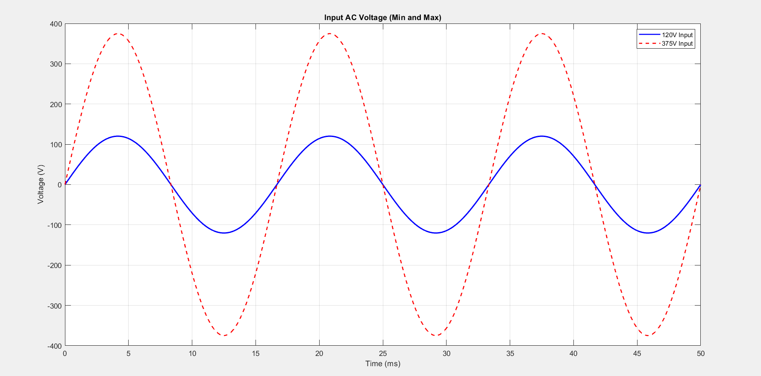
Figure 15: Input AC

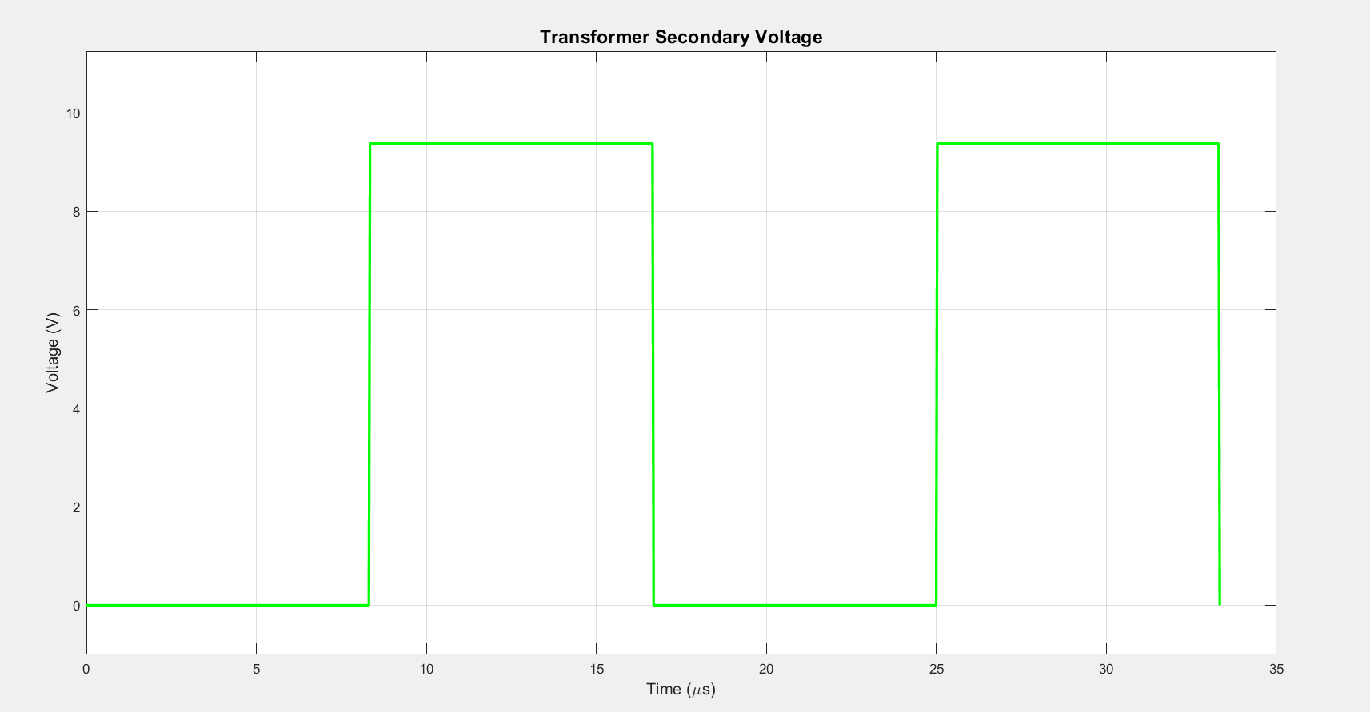
Figure 16: Transformer Secondary Voltage
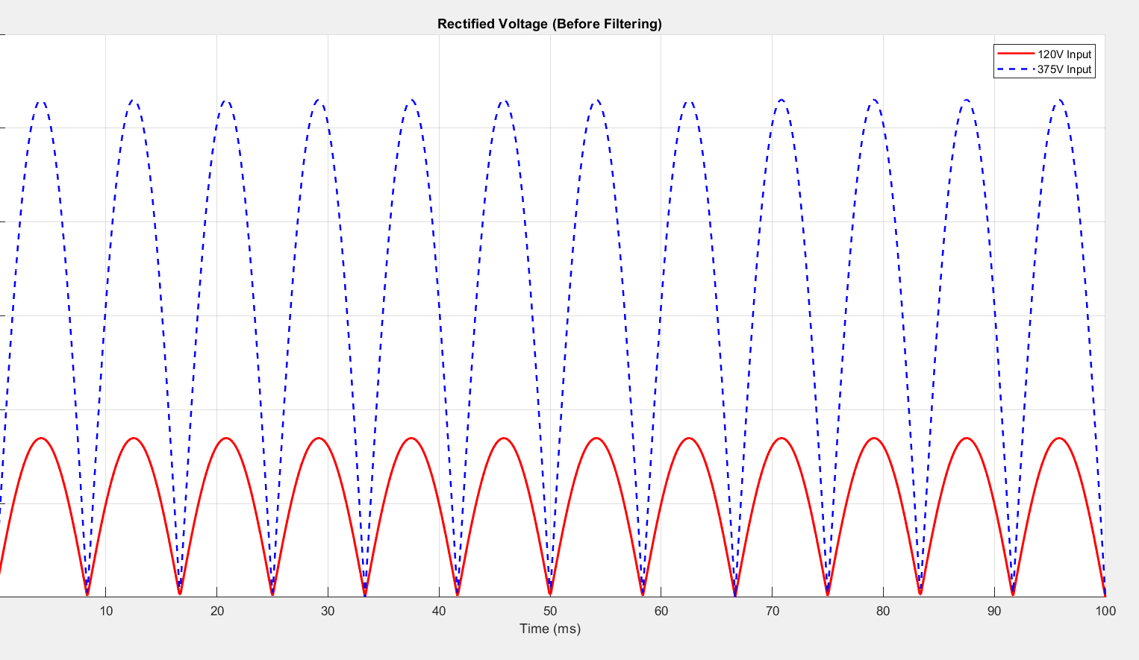
Figure 17: Rectified Voltage
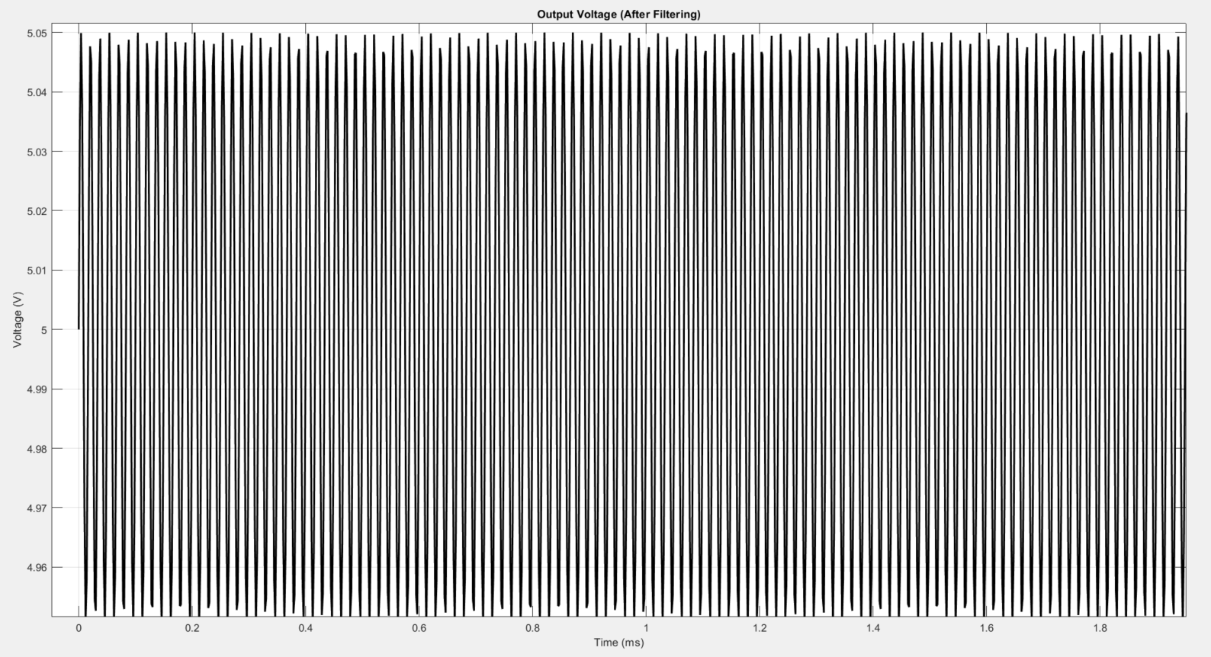
Figure 18: Filtering Voltage
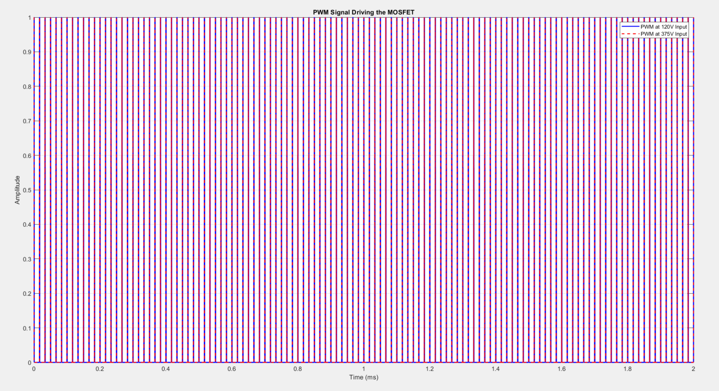
Figure 19: PWM Signal
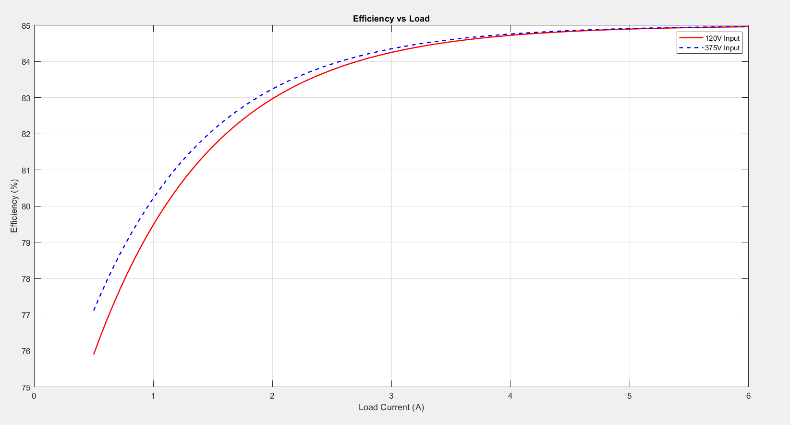
Figure 20: Efficiency vs Load
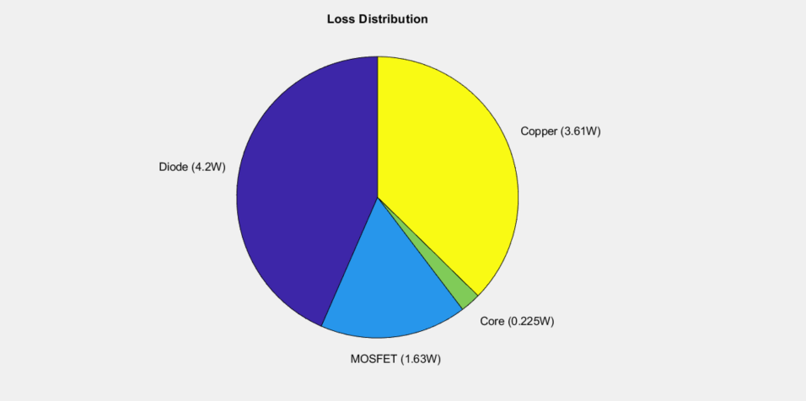
Figure 21: Loss Distribution
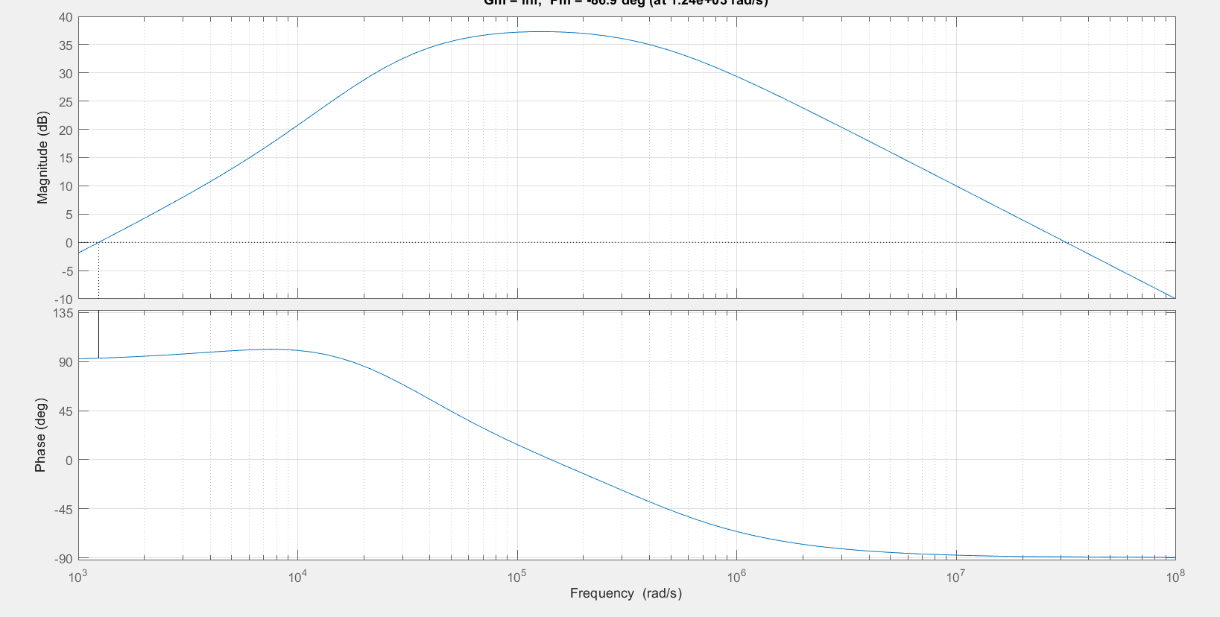
Figure 22: Magnitude, Pulse, Frequency (BD)

